**Karan Arora**  **R.L. Institute M: 9416974837**

**Max Time : 2 hr** **Class = 12th Chemistry Max Marks : 50**

**MID TERM EXAM – 1 CODE : A**

1. Multiple choice questions : **[ 1 X 5 = 5]**
2. In the following diagram point, ‘X’ represents :

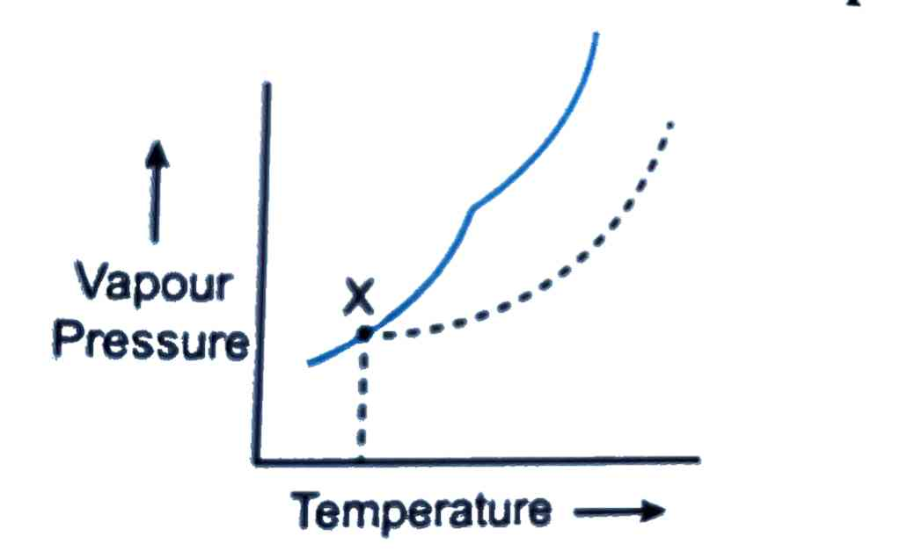

|  |  |
| --- | --- |
| a) Boiling point of solution | b) Freezing point of solvent |
| c) Boiling point of solvent | d) Freezing point of solution |

1. The electrode potential data are given below

Fe3+ + e –  Fe2+ , E0 = + 0.77V ; Al3+ + 3e –  Al , E0 = - 1.66V ;

Br2  + 2e –  2 Br –  , E0 = + 1.80V

Based on the data, the reducing power of Fe2+ , Al , Br –  increases in the order.

|  |  |  |  |
| --- | --- | --- | --- |
| a) Br –  < Fe2+ < Al | b) Fe2+ < Al < Br – | c) Al < Br –  < Fe2+ | d) Al < Fe2+ < Br – |

1. Which of the following analogy is correct?

a) third order : Litre2 mol – 2 second – 1 :: second order : Litre mol – 1 second – 1

b) third order : second – 1 :: second order : Litre mol – 1 second – 1

c) third order : second – 1 :: second order : Mol Litre– 1 second – 1

d) third order : Mol Litre– 1 second – 1 :: second order : second – 1

1. Which of the following is the reason for zinc not exhibiting variable oxidation state?

|  |  |
| --- | --- |
| a) Inert pair effect | b) Completely filled 3d subshell |
| c) Completely filled 4s subshell | d) Common ion effect |

1. EDTA is a

|  |  |  |  |
| --- | --- | --- | --- |
| a) Monodentate ligand | b) Bidentate ligand | c) Ambidentate ligand | d) Hexadentate ligand |

1. What is meant by half-life period? Derive an expression for half-life period in case of first order reaction. **[ 2 ]**
2. Why is +2 oxidation state of manganese quite stable while the same is not true for iron? **[ 2 ]**
3. Explain why [Fe (H2O)6 ]3+ has magnetic moment value of 5.92 BM whereas [Fe (CN)6 ] 3 – has value of only 1.74 BM. **[ 2 ]**
4. Henry’s law constant for the molarity of methane in benzene at 298 K is 4.27 x 105 mm Hg. Calculate the solubility of methane in benzene at 298 K under 760 mm Hg. **[ 2 ]**
5. Calculate the emf of the cell in which of the following reaction takes place : **[ 2 ]**

Ni (s) + 2 Ag+ (0.002 M) Ni2+ (0.160 M) + 2 Ag (s) ; $E_{cell}^{o}$ = 1.05 V

1. Define osmosis and osmotic pressure. **[ 2 ]**
2. Write the chemistry of recharging and discharging the lead storage battery. **[ 2 ]**
3. Write down the electronic configuration of : **[ 3 ]**

|  |  |  |  |  |  |
| --- | --- | --- | --- | --- | --- |
| a) Cr3+ | b) Cu+ | c) Co2+ | d) Mn2+ | e) Pm3+ | f) Ce4+ |

1. On the basis of figure given below, answer the following questions : **[ 3 ]**

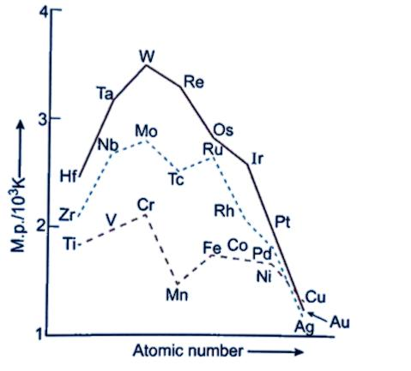

(a) Why manganese have lower melting point than Chromium?

(b) Why do transition metals of 3d series have lower melting points as compared to 4d series?

(c) In the third transition series, identify and name the metal with the higher melting point.

1. Show that in first order reaction, time required for completion of 99.9% is 10 times that of half-life ($t_{1/2}$) of the reaction. **[ 3 ]**
2. A 0.01 m aqueous solution of AlCl3 freezes at – 0.068˚C. Calculate the percentage of dissociation [Given that : Kf for water = 1.86 K/m] **[ 3 ]**
3. Write the name, the structure and magnetic behavior of each one of the following complexes :

(a) [Pt (NH3)2 Cl (NO2)] (b) [Co (NH3)4 Cl2] Cl **[ 3 ]**

1. For the reaction , 2 NO (g) + Cl2 (g) 2 NOCl (g) , the following data were collected. All the measurements were taken at 263 K. **[ 3 ]**

|  |  |  |  |
| --- | --- | --- | --- |
| Experiment | Initial [NO]  (M) | Initial [Cl2]  (M) | Initial rate of disappearance of Cl2  (M/min) |
| 1 | 0.15 | 0.15 | 0.60 |
| 2 | 0.15 | 0.30 | 1.20 |
| 3 | 0.30 | 0.15 | 2.40 |
| 4 | 0.25 | 0.25 | ? |

(i) Write the expression for rate law.

(ii) Calculate the value of rate constant and specify its units.

(iii) What is the initial rate of disappearance of Cl2 in experiment 4?

1. Explain : (a) Order of recation (b) Ambidentate ligand with example (c) Cell constant **[ 3 ]**
2. (a) Calculate the degree of dissociation ($α$) of acetic acid if its molar conductivity ($∧_{m}$) is 39.05 S cm2 mol – 1 .[Given = 349.6 S cm2 mol – 1 and = 40.9 S cm2 mol – 1]

(b) For a 5 % solution of urea (Molar mass = 60 g/mol), calculate the osmotic pressure at 300 K.

[R = 0.0821 K atm J – 1 mol– 1].

(c) For a reaction ; A + B → Products, the rate law is given by r = k ${[A]}^{1/2}$ ${[B]}^{2}$. What is the order of the reaction? **[ 5 ]**

1. (a) Define Azeotropes. What type of azeotropes is formed by negative deviation from Raoult’s law? Give an example.

(b) Calculate Go and Log Kc for the following reaction :

Cd2+ (aq) + Zn (s) Zn2+ (aq) + Cd (s)

[Given : $E_{{Cd}^{2+}/Cd}^{o}$ = $-$ 0.403 volt , $E_{{Zn}^{2+}/Zn}^{o}$ = $-$ 0.763 volt ] **[ 5 ]**

**Or**

1. (a) The conductivity of 0.2 M solution of KCl at 298 K is 0.025 S cm – 1. calculate its molar conductivity.

(b) Define : Molarity and Molecularity

(c) Write unit of ‘K’ for First order reaction. **[ 5 ]**

**Karan Arora**  **R.L. Institute M: 9416974837**

**Max Time : 2 hr** **Class = 12th Chemistry Max Marks : 50**

**MID TERM EXAM – 1 CODE : B**

1. Multiple choice questions : **[ 1 X 5 = 5]**
2. Which of the following analogy is correct?

a) third order : Litre2 mol – 2 second – 1 :: second order : Litre mol – 1 second – 1

b) third order : second – 1 :: second order : Litre mol – 1 second – 1

c) third order : second – 1 :: second order : Mol Litre– 1 second – 1

d) third order : Mol Litre– 1 second – 1 :: second order : second – 1

1. EDTA is a

|  |  |  |  |
| --- | --- | --- | --- |
| a) Monodentate ligand | b) Bidentate ligand | c) Ambidentate ligand | d) Hexadentate ligand |

1. Which of the following is the reason for zinc not exhibiting variable oxidation state?

|  |  |
| --- | --- |
| a) Inert pair effect | b) Completely filled 3d subshell |
| c) Completely filled 4s subshell | d) Common ion effect |

1. The electrode potential data are given below

Fe3+ + e –  Fe2+ , E0 = + 0.77V ; Al3+ + 3e –  Al , E0 = - 1.66V ;

Br2  + 2e –  2 Br –  , E0 = + 1.80V

Based on the data, the reducing power of Fe2+ , Al , Br –  increases in the order.

|  |  |  |  |
| --- | --- | --- | --- |
| a) Br –  < Fe2+ < Al | b) Fe2+ < Al < Br – | c) Al < Br –  < Fe2+ | d) Al < Fe2+ < Br – |

1. In the following diagram point, ‘X’ represents :



|  |  |
| --- | --- |
| a) Boiling point of solution | b) Freezing point of solvent |
| c) Boiling point of solvent | d) Freezing point of solution |

1. Calculate the emf of the cell in which of the following reaction takes place : **[ 2 ]**

Ni (s) + 2 Ag+ (0.002 M) Ni2+ (0.160 M) + 2 Ag (s) ; $E_{cell}^{o}$ = 1.05 V

1. What is meant by half-life period? Derive an expression for half-life period in case of first order reaction. **[ 2 ]**
2. Write the chemistry of recharging and discharging the lead storage battery. **[ 2 ]**
3. Why is +2 oxidation state of manganese quite stable while the same is not true for iron? **[ 2 ]**
4. Explain why [Fe (H2O)6 ]3+ has magnetic moment value of 5.92 BM whereas [Fe (CN)6 ] 3 – has value of only 1.74 BM. **[ 2 ]**
5. Henry’s law constant for the molarity of methane in benzene at 298 K is 4.27 x 105 mm Hg. Calculate the solubility of methane in benzene at 298 K under 760 mm Hg. **[ 2 ]**
6. Define osmosis and osmotic pressure. **[ 2 ]**
7. Explain : (a) Order of recation (b) Ambidentate ligand with example (c) Cell constant **[ 3 ]**
8. Write down the electronic configuration of : **[ 3 ]**

|  |  |  |  |  |  |
| --- | --- | --- | --- | --- | --- |
| a) Cr3+ | b) Cu+ | c) Co2+ | d) Mn2+ | e) Pm3+ | f) Ce4+ |

1. Show that in first order reaction, time required for completion of 99.9% is 10 times that of half-life ($t_{1/2}$) of the reaction. **[ 3 ]**
2. Write the name, the structure and magnetic behavior of each one of the following complexes :

(a) [Pt (NH3)2 Cl (NO2)] (b) [Co (NH3)4 Cl2] Cl **[ 3 ]**

1. On the basis of figure given below, answer the following questions : **[ 3 ]**



(a) Why manganese have lower melting point than Chromium?

(b) Why do transition metals of 3d series have lower melting points as compared to 4d series?

(c) In the third transition series, identify and name the metal with the higher melting point.

1. For the reaction , 2 NO (g) + Cl2 (g) 2 NOCl (g) , the following data were collected. All the measurements were taken at 263 K. **[ 3 ]**

|  |  |  |  |
| --- | --- | --- | --- |
| Experiment | Initial [NO]  (M) | Initial [Cl2]  (M) | Initial rate of disappearance of Cl2  (M/min) |
| 1 | 0.15 | 0.15 | 0.60 |
| 2 | 0.15 | 0.30 | 1.20 |
| 3 | 0.30 | 0.15 | 2.40 |
| 4 | 0.25 | 0.25 | ? |

(i) Write the expression for rate law.

(ii) Calculate the value of rate constant and specify its units.

(iii) What is the initial rate of disappearance of Cl2 in experiment 4?

1. A 0.01 m aqueous solution of AlCl3 freezes at – 0.068˚C. Calculate the percentage of dissociation [Given that : Kf for water = 1.86 K/m] **[ 3 ]**
2. (a) The conductivity of 0.2 M solution of KCl at 298 K is 0.025 S cm – 1. calculate its molar conductivity.

(b) Define : Molarity and Molecularity

(c) Write unit of ‘K’ for First order reaction. **[ 5 ]**

1. (a) Define Azeotropes. What type of azeotropes is formed by negative deviation from Raoult’s law? Give an example.

(b) Calculate Go and Log Kc for the following reaction :

Cd2+ (aq) + Zn (s) Zn2+ (aq) + Cd (s)

[Given : $E_{{Cd}^{2+}/Cd}^{o}$ = $-$ 0.403 volt , $E_{{Zn}^{2+}/Zn}^{o}$ = $-$ 0.763 volt ] **[ 5 ]**

**Or**

1. (a) Calculate the degree of dissociation ($α$) of acetic acid if its molar conductivity ($∧_{m}$) is 39.05 S cm2 mol – 1 .[Given = 349.6 S cm2 mol – 1 and = 40.9 S cm2 mol – 1]

(b) For a 5 % solution of urea (Molar mass = 60 g/mol), calculate the osmotic pressure at 300 K.

[R = 0.0821 K atm J – 1 mol– 1].

(c) For a reaction ; A + B → Products, the rate law is given by r = k . What is the order of the reaction? **[ 5 ]**